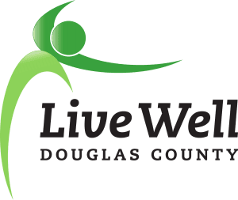

Vision: Communities where we all thrive.
Mission: Leading a movement to build communities that support the health and well-being of all.

Our Story
Established in 2008, LiveWell Douglas County is a cross-sector community coalition that works to improve the health and well-being of residents of Lawrence and Douglas County. Utilizing a collective impact framework, LiveWell Douglas County understands that community-wide issues require long-term engagement from numerous community agencies and individuals. We provide a platform where individuals and organizations come together on collective work that affects change at a level greater than any one institution could achieve alone. LiveWell Douglas County has set an example across Kansas, demonstrating that collaboration can lead to system and community-wide change and improvement.
Since its inception, LiveWell Douglas County has grown to include hundreds of community residents and scores of community organizations. Local achievements are numerous, and include the founding of WorkWell Lawrence and Lawrence Complete Streets, establishment of marathon clubs at local schools, establishment and growth of summer food programs across Douglas County, building trails at Eudora Elementary School, establishment and growth of Double Up Food Bucks, introduction of FuelGood to bring healthy foods and beverage options to public spaces, increased food recovery and redistribution efforts, and creation of the Lawrence Loop.
In 2013, LiveWell restructured its efforts to align with the Douglas County Community Health Plan in the areas of nutrition and physical activity. In 2013 and again in 2018, LiveWell has served as primary convener for efforts in the five-year Douglas County Community Health Plan areas of nutrition and physical activity. LiveWell is recognized as the primary convener and leader in these areas, and has served as an incubator for growing community-based efforts, including Friends of the Lawrence Area Trails and the Lawrence Loop which have cumulatively leveraged hundreds of thousands of dollars in funding for our communities. LiveWell has provided the required collaborating structure for obtaining matching funds for municipal and county efforts from the state, and has enabled grant funding to the Douglas County community from the Kansas Department of Health and Environment, the Kansas Health Foundation, and the Center for Disease Control and Prevention. LiveWell was also approached by the STA CARE Center to create a LiveWell Sexual Violence Prevention Work Group, which enabled them to receive multiple years of funding from the Kansas Department of Health and Environment to address risk and protective factors for sexual violence.
Over the last decade, we’ve seen improved access to nutritious food, increased connectivity of bike and pedestrian networks, programs that support the health of our youth, support for healthier work environments, advances in policies to minimize tobacco use and purchase, and work to prevent sexual violence. As we look forward to the next 10 years, we hope to build on these successes while addressing gaps and inequities in health through the type of strong, community-based support that LiveWell was founded on.

Our Future
LiveWell has a strong base of engaged community stakeholders, as well as communications, planning, and data support from the Lawrence-Douglas County Health Department and K-State Research and Extension – Douglas County. We would like to seize the opportunity to accelerate the growth of local efforts by providing staff support for institutional memory and continuity, grant writing, communications, and to strengthen community engagement by hiring an Executive Director. This position will further leverage the incredible in-kind donations of time provided by community members, and allow dedicated time for securing additional support and resources to expand LiveWell’s efforts in Douglas County. This will strengthen our ability to serve as the cross-sectoral community collaboration that can grow our competitiveness for funding from state, federal, and private foundation sources.

LiveWell will remain focused on implementing policy, system, and environmental changes for a healthier Douglas County. Goals our work groups are addressing include:
- Creating school and out-of-school environments where children thrive
- Creating healthy built environments to support physical activity and active transit
- Addressing social determinants of health and reducing risk for sexual violence
- Creating healthier workplaces, where most adults spend the majority of their waking hours
- Ensuring access to nutritious food for our most vulnerable community members
- Decreasing the use of tobacco products, including delaying age of first use

LiveWell is a critical asset for improving health and well-being in Douglas County. We hope you will join the effort to establish this critical staffing position. We look forward to sustaining and growing the next decade of efforts to improve conditions for health for all.
With thanks,
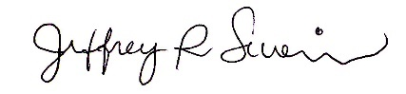
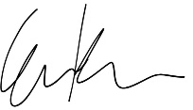
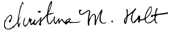

The 2018-2019 LiveWell Douglas County Executive Team

Jeff Severin, Chair
Christina Holt, Chair Elect
Elizabeth Keever, Past Chair

